KALISHER TRUST PRE-LOVED CLOTHING FAIR
AT MIDDLE TEMPLE, 12 – 7pm
FRIDAY 10TH FEBRUARY 2023

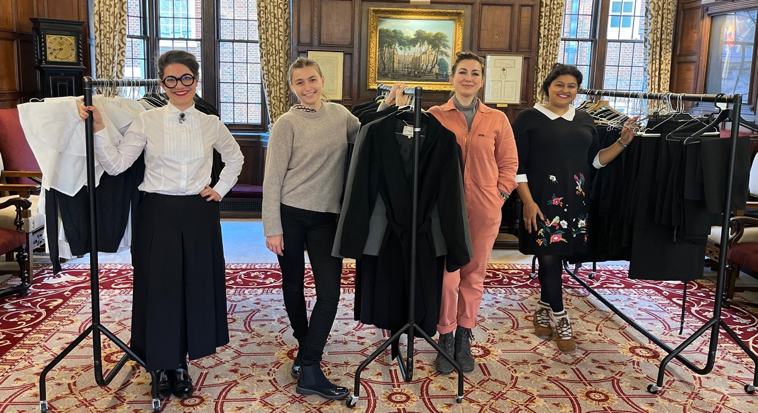
The Kalisher Trust is holding a second pre-loved clothing fair for students and pupils. The fair will include suits, as well as formal clothing suitable for dining at the Inn, for men and for women.
All items free; a limit of 5 items per person; bring your own bag!

There will be a pop-up store from legal outfitters Ivy & Normanton all day too, so you can be fitted for formal courtwear.

We have a very special wig & gown set, owned by the late John Hicks KC, which we will award to a student from an under-represented group.
For more details on gown applications, follow us on twitter @kalisher trust

Do you have good quality pre-loved clothes to donate?
Please send them to Kalisher trustee Danielle Manson at Garden Court Chambers

Contact us via twitter @kalisher trust
We are very grateful for the continued support and generosity of Middle Temple in hosting us for this event which will help those at the start of their career at the Bar

